# **Project 2: Responsive Layout**

## **While working on your project and before you submit it**

* **Validate your CSS & HTML: see our** [**validation checklist**](https://docs.google.com/document/d/1rwLgab3ac0tOB8cOHx0XZMuy-oxA33qJqzh_cBs5Kdk/edit#) **if you need help**

## **How to succeed at this project**

Here are the things you need to do pass this project. Make sure you complete them ***before*** you turn in your project.

* **Include a viewport meta tag in the head of your HTML document.**  
  <meta name=viewport content="width=device-width, initial-scale=1">  
  *Learn more:* [Configuring the Viewport](https://developers.google.com/speed/docs/insights/ConfigureViewport#overview)
* **Create a CSS folder and put the styles.css file inside it.**You might also create a folder for images, and, if you download Google fonts, you might have a folder for fonts. The files in your workspace should look something like this:  
  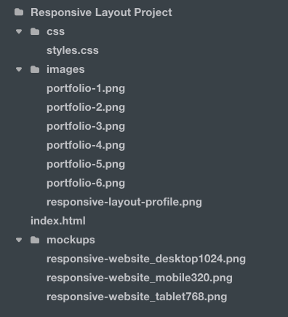  
  If you need help with Treehouse workspaces watch this video: [Using Treehouse Workspaces](https://teamtreehouse.com/library/using-treehouse-workspaces)
* **In your CSS file, use min-width properties to create your media queries and design for tablets at 768px and desktop screens at 1024px**.
  + *Learn more:* [Using a Mobile First Approach](https://teamtreehouse.com/library/css-layout-basics/getting-started-with-css-layout/using-a-mobile-first-approach)
  + *Learn more:* [Adding Media Queries for Large Screens](https://teamtreehouse.com/library/css-layout-basics/css-layout-project/adding-media-queries-for-large-screens)
  + Learn more: [The min-width Property](https://developer.mozilla.org/en-US/docs/Web/CSS/min-width)
* **Make sure your design matches the layout of the mockups.**
  + **Mobile:** look at the **responsive-website_mobile320.png** file in your workspace.
  + **Tablet:** look at the **responsive-website_tablet768** file in your workspace.
  + **Desktop:** look at the **responsive-website_desktop1024.png** file in your workspace.
* **Use a Google Font to make your text look cooler**
  + *Learn more:* [Web Fonts with @font-face](https://teamtreehouse.com/library/web-fonts-with-fontface)
  + *Learn more*: [Getting started with Google Fonts](https://developers.google.com/fonts/docs/getting_started?hl=en)
* **In the index.html file, link the navigation bar links to different sections using IDs to link to anchor tags**
  + *Learn more:* [Linking to sections of a web page](https://teamtreehouse.com/library/linking-to-sections-of-a-web-page)

## **Structuring Your HTML for this Project**

There are many ways to structure the HTML for this project. A simple approach could look like the diagram on the next page, with 3 main areas -- header, main , and footer. You'll nest divs and other HTML elements inside those. For example, one of the portfolio units could be structured like this:

-- div

-- image

-- headline

-- paragraph

You'll create one unit like this for each portfolio piece, and put all of those inside a container element like an HTML <main> tag.

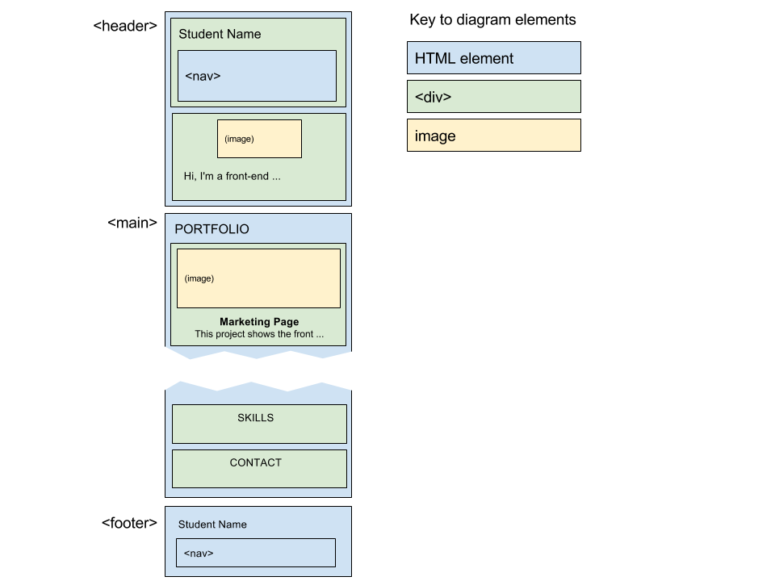

## **Tip**

For hiding/showing the "Back to Top" link which appears at the bottom of the page on the mobile design but isn't visible in the table and desktop sizes you can combine media queries with the CSS display property. Learn more about the display property in this video: [Display Values](https://teamtreehouse.com/library/css-basics/the-box-model/display-values)

## **Practice**

If you want to practice some basic CSS concepts that you'll use in this project check out these helpful practice session workshops:

* [**Practice the CSS Box Model**](https://teamtreehouse.com/library/practice-the-css-box-model)
* [**Practice CSS Floats**](https://teamtreehouse.com/library/practice-css-floats)
* [**Practice Media Queries**](https://teamtreehouse.com/library/practice-media-queries)
* [**Practice CSS Selectors**](https://teamtreehouse.com/library/practice-css-selectors)